Install asnsible
1st go to Oracle virtual box and create a snapshot machine
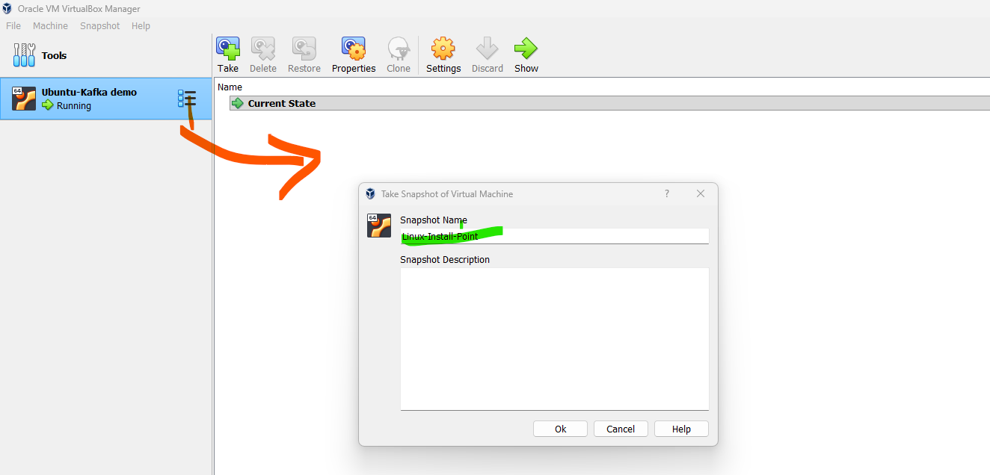

Once this was setup, we need install the ansible through a command line—follow the below video
https://www.youtube.com/watch?v=h8z1h2rvYA0-- to setup username and password
https://www.youtube.com/watch?v=YbmBMZI3mxA - to download and install Ansible

to check ansible version do the following
ansible –version
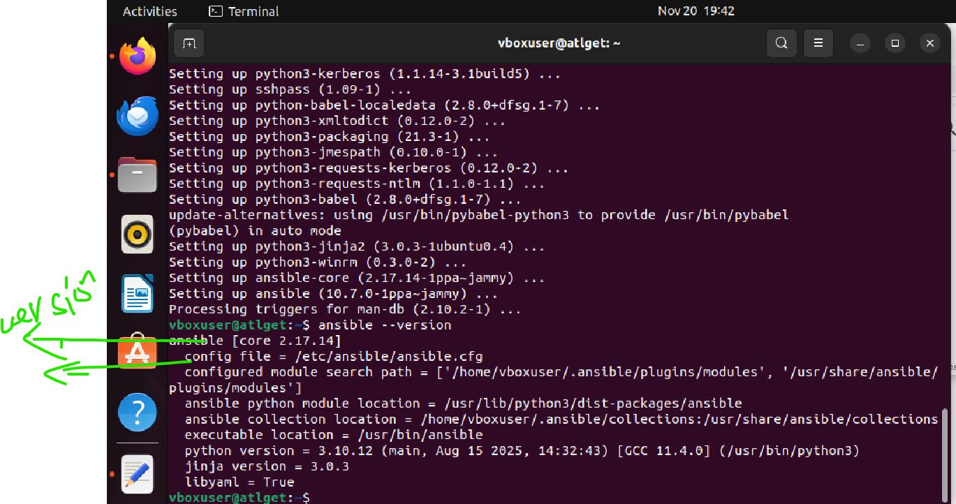
Also we can check the Python versions like below
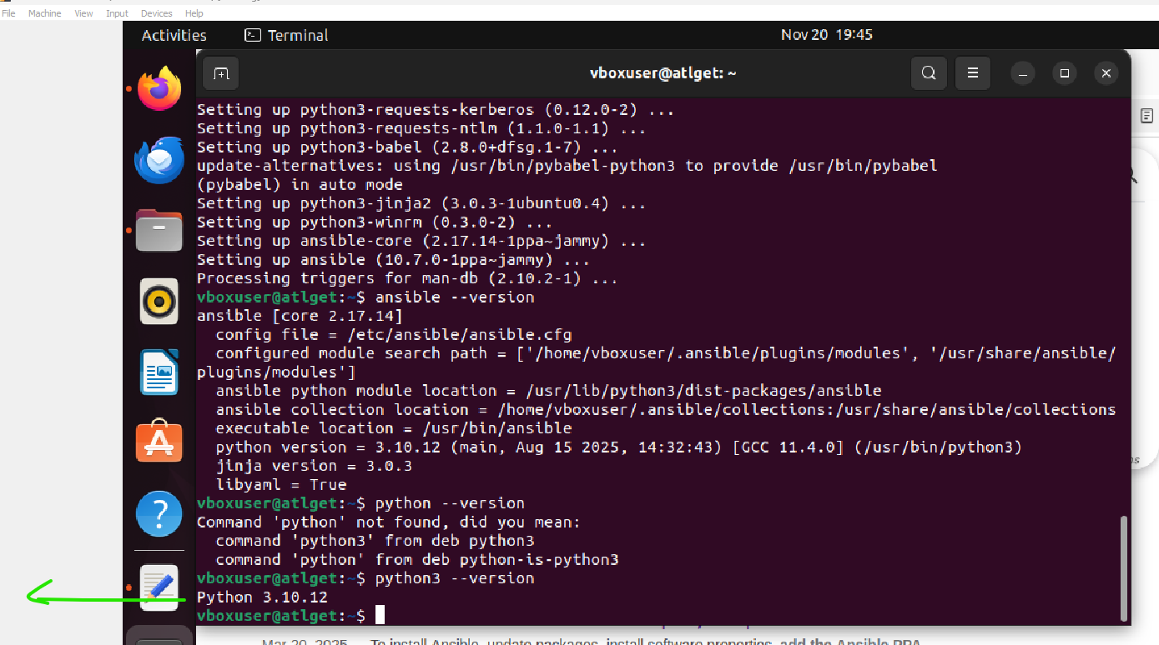

SSH key is setup like below
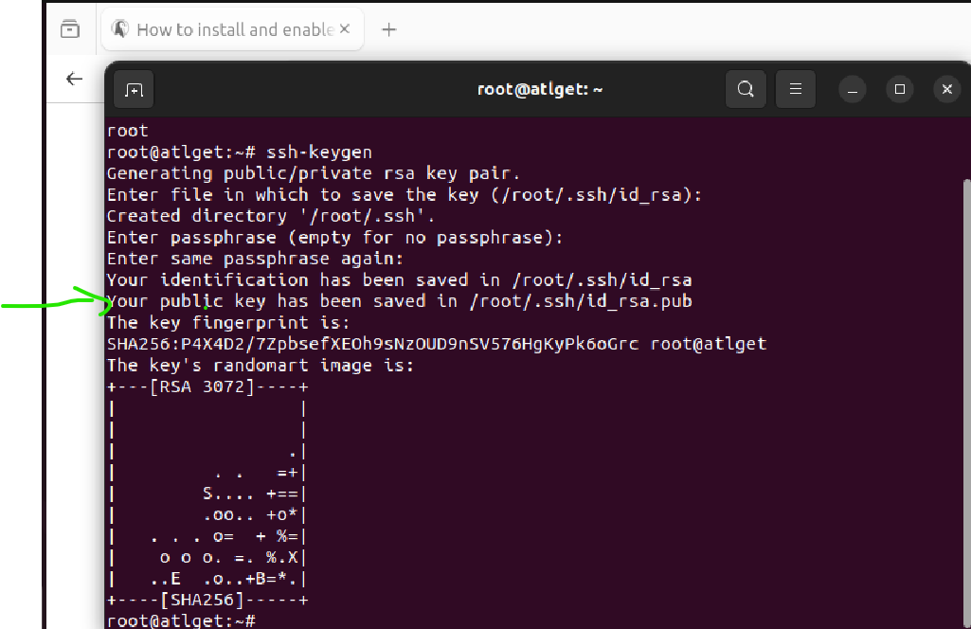

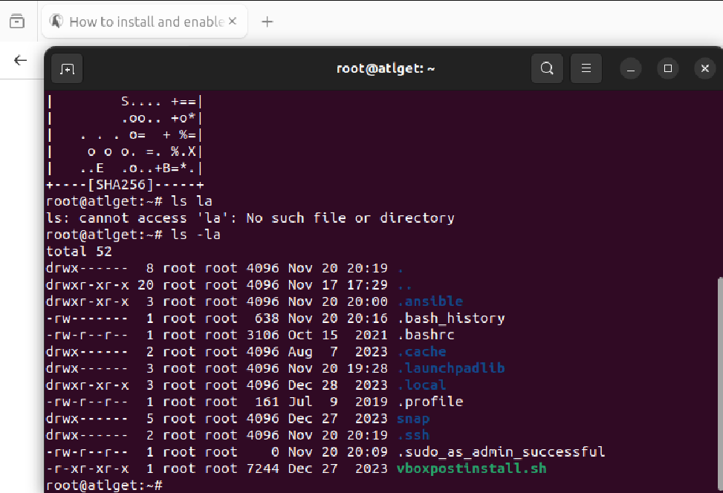

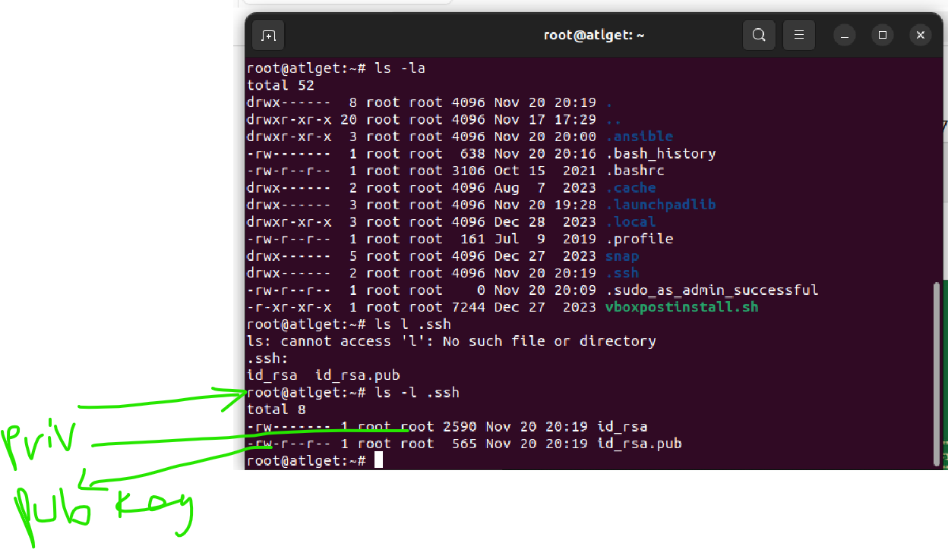
Create my first playbook like below
In yaml

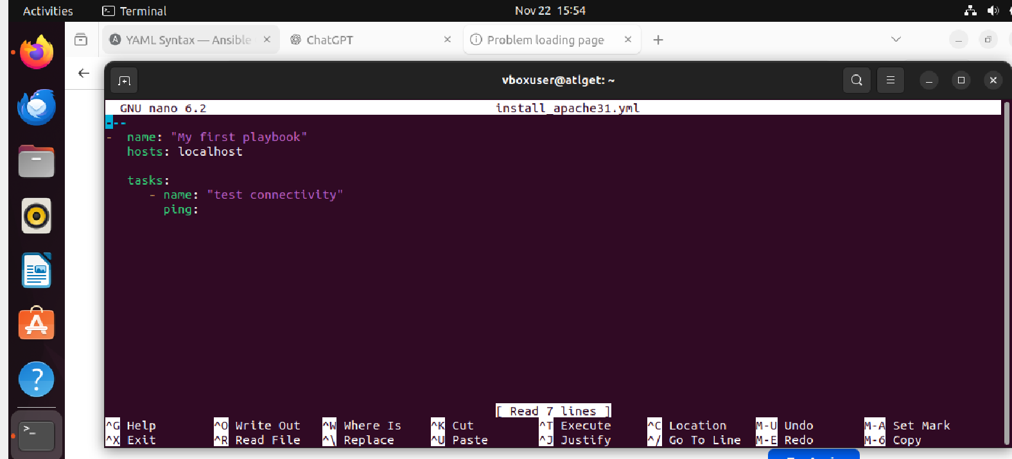
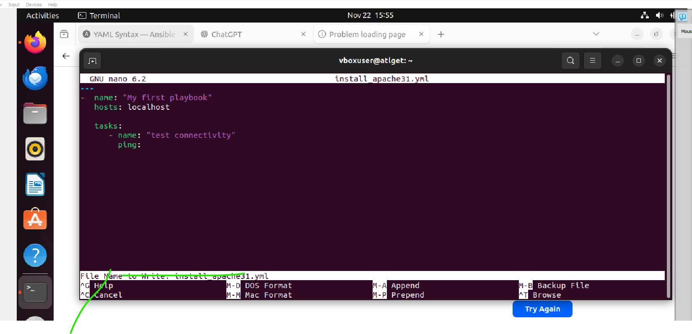

Then run the ansible playbook for install_apache31.yml

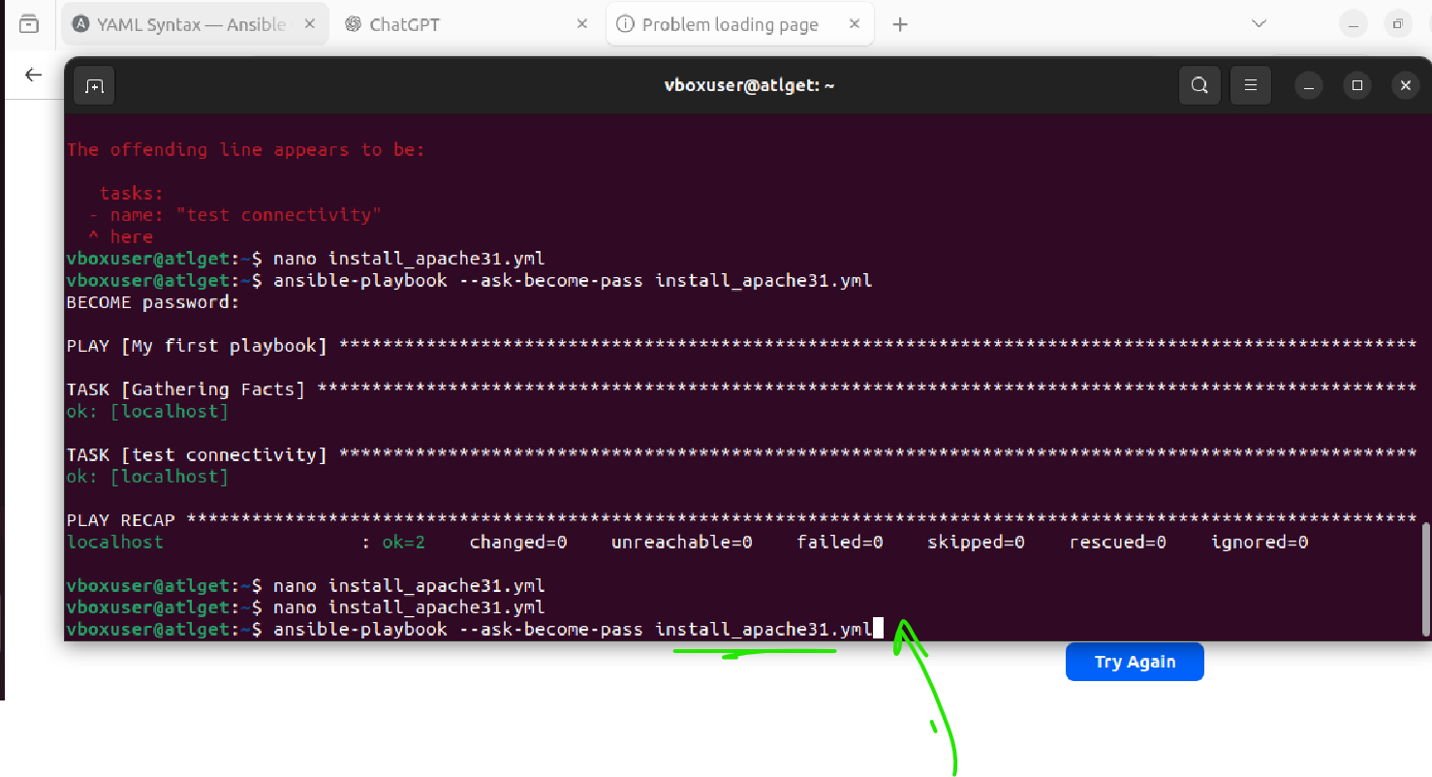
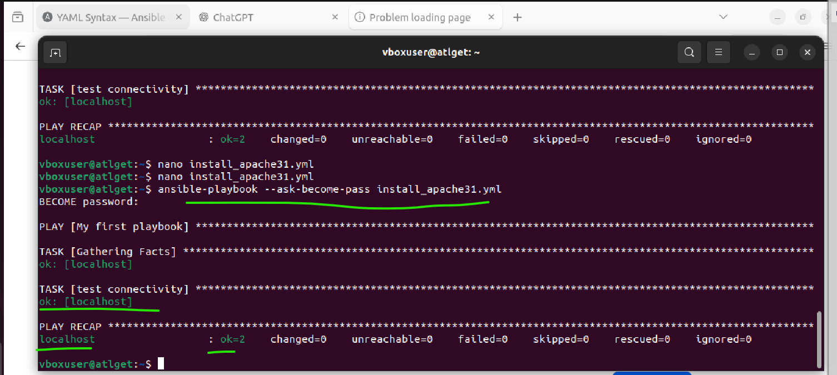
Create a new yaml file for hellow world

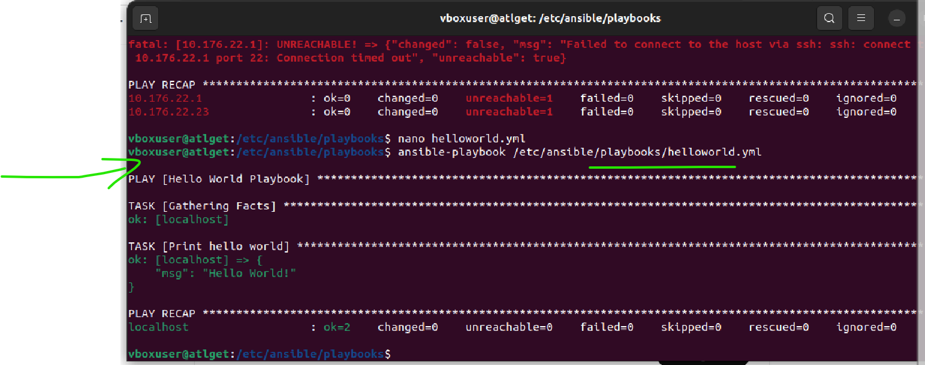

Create Multiple Tasks Playbook
Create multiple tasks like below and run

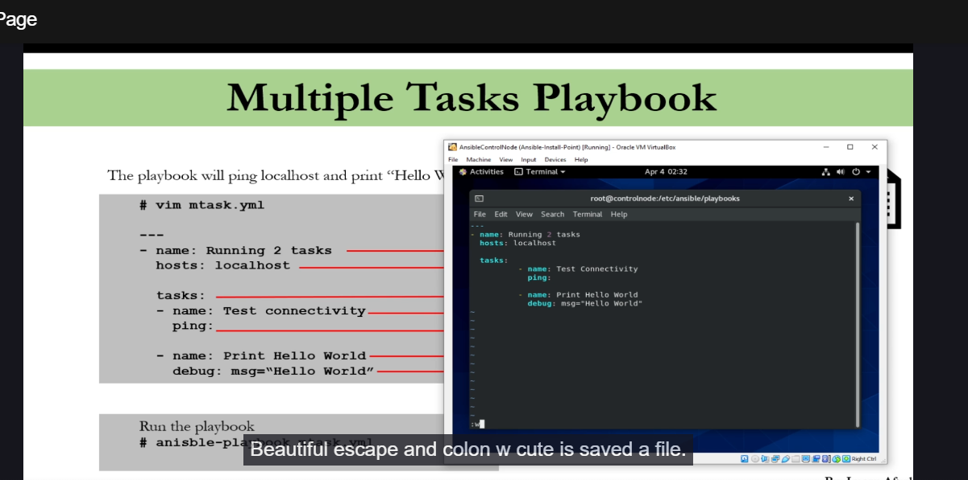
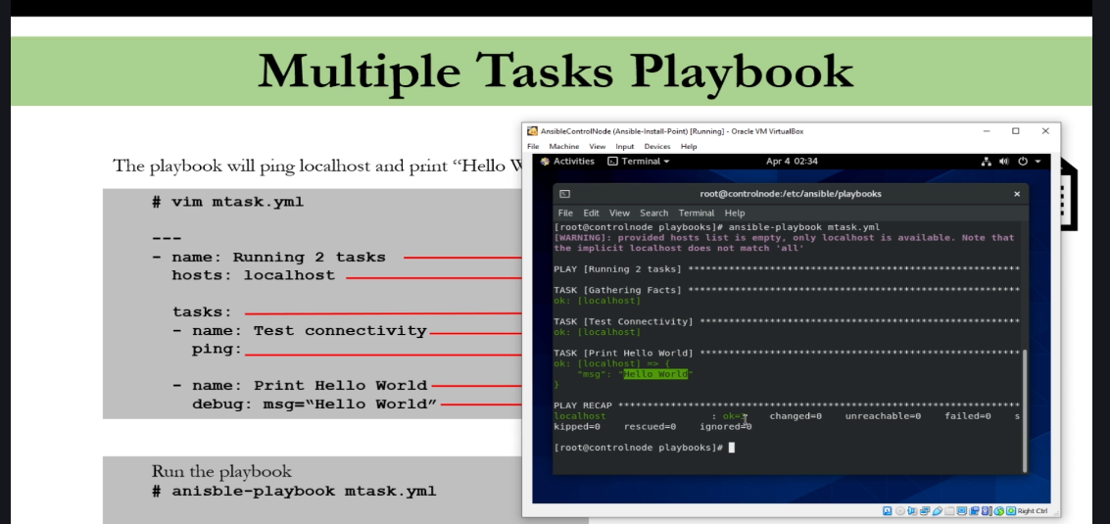
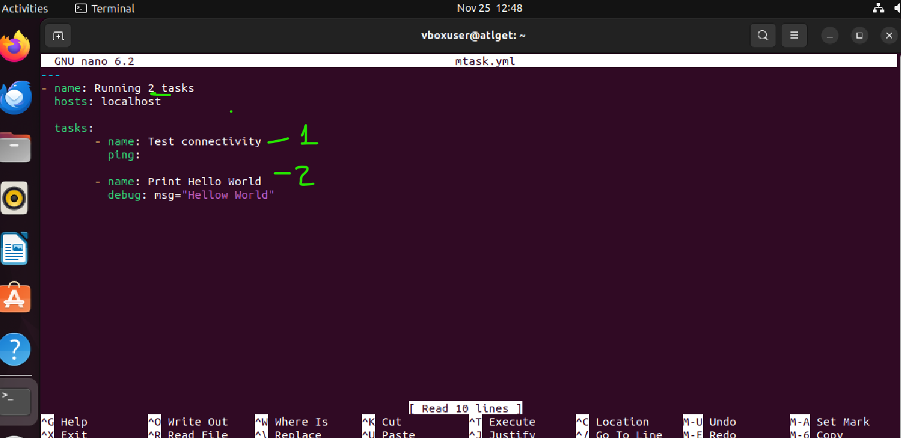
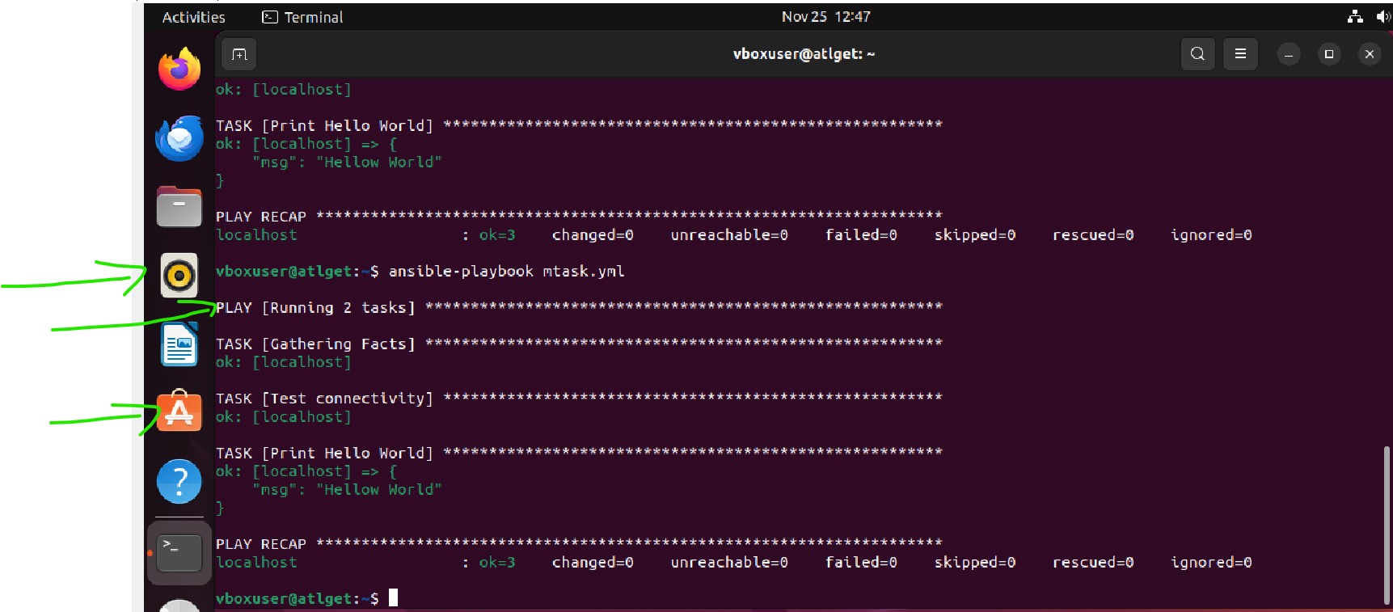

Installing and start/running a package using Ansible

